中文标题（concise, within 20 characters, avoid foreign abbreviations, in Heiti size 2）
张 三¹， 李 四²， 王五五³， 赵六六^{1*}（corresponding author marked with *, in Fangsong, size 4）

（1中国科学院安徽光学精密机械研究所中国科学院环境光学与技术重点实验室， 安徽 合肥 230031；
2中国科学技术大学自动化系， 安徽 合肥 230036；
3 环境保护部卫星环境应用中心， 北京 100094）
(full name for affiliation, specific to secondary department. in Songti, small size 5）

摘要： 中文摘要 (The abstract aims to provide a concise overview of the paper without adding comments or supplementary explanations. It should clearly and precisely present the research objectives, principles, and conclusions, and be relatively self-contained. The abstract should focus on four key elements: research objectives, methods, results, and conclusions, with the latter two being the most important. When applying these principles, the abstract may, in some cases, include the main subjects and scope of the study, as well as other important information of informational value. It should not contain content from the introduction, nor interpret or comment on the paper; it must not simply repeat information already presented in the title, introduction, or conclusion. Non-publicly known symbols and terms should not be used, and references are allowed only if the paper confirms or disputes previously published work. Abbreviations, short forms, and codes must be explained at first occurrence unless they are clearly understood by readers in the same field. Figures, tables, equations, and chemical structures should not be included. The Chinese abstract is recommended to be around 300 characters, in Songti, small size 5)
关键词： 关键词1；关键词2；关键词3；关键词4 (There should be 4 to 6 keywords, with the first keyword corresponding to the first OCIS code, in Songti, small size 5)
中图分类号：O431.2；P426 文献标识码A
（look up for CLC number: http://www.ztflh.com/ ）

Title in English (The English title should be consistent in meaning with the Chinese title, avoid abbreviations as much as possible, and use lowercase letters except for the first letter. Calibri, size 3)
ZHANG San¹, LI Si², WANG Wuwu³, ZHAO Liuliu^{1*} (Times New Roman, size 5)
(1 Key Laboratory of Environment Optics and Technology, Anhui Institute of Optics and Fine Mechanics, Chinese Academy of Sciences, Hefei 230031, China;
2 Department of Automation, University of Science and Technology, Hefei 230026, China;
3 Satellite Environment Center, Ministry of Environmental Protection, Beijing 100094, China)（Times New Roman, in small size 5）
Abstract: Content of abstract (The English abstract must be provided as a structured, long abstract (approximately 800 words). For general research articles, it should include the following sections: Objective, Methods, Results and Discussion, and Conclusions. For review articles, it should include the following three parts: Significance, Progress, and Conclusions and Prospects.. in small size 5)
Key words: key word1; key word2; key word3; key word4(Chinese and English keywords should correspond one by one, with lowercase initial letters, separated by semicolons, in small size 5)
0 Introduction(Size 4, Heiti, the main text should be in Songti size 5, with 1.5 line spacing, and formatted in full column width.）
生物质燃烧（包括农业秸秆焚烧、森林火灾、草原火灾等）是全球痕量气体和颗粒物排放的重要来源之一；根据EDGARv3.2FT2000排放清单，在2000年全球污染物排放中，生物质燃烧排放的CO占51%，NO_{X}占20%^{[1]}。最新排放清单研究表明：生物质燃烧排放的一次细颗粒物占全球的26%～73%，黑炭占33%～41%^{[2-3]}。生物质燃烧是重要的气候强迫因子,对局地、区域乃至全球的空气质量产生影响；生物质燃烧排放的颗粒物严重影响人体健康，影响太阳辐射和云的特性，也使局地和区域能见度恶化；排放的许多痕量气体（如非甲烷有机化合物NMOC和氮氧化物NO_{X}）导致下风向O₃的形成^{[4]}，排放的CO₂会对区域的碳循环产生影响^{[5]}。因此生物质燃烧污染物排放的准确估算对区域大气化学过程和气候模拟及大气污染防治、空气质量改善具有重要意义。
[The writing of the introduction directly affects the reader’s interest in further understanding the article. It is recommended to include the following content: (1) a review of the background in the research field; (2) a detailed description of previous research results by other scholars; (3) a statement of why further or additional research is needed; (4) an explanation of the objectives of the current study; (5) a brief overview of the research work conducted in this paper; (6) the significance of the study results (optional). In addition, the introduction should not repeat the abstract or conclusion; figures, tables, and equations should be avoided as much as possible; the text should be described objectively, without strongly subjective terms such as “first.” Please also pay attention to the format of English abbreviations, e.g., Organic Aerosol (OA).]
1 实验方案与装置
1.1 Second level heading (Size 5, Heiti)
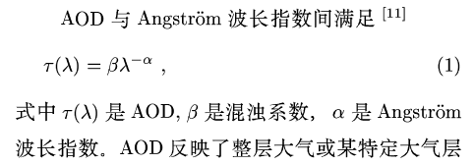
[Please note the following: 1. Equations must be edited using MathType; image-based equations are not accepted. 2. Variables are generally represented by a single letter and may include superscripts or subscripts. Multi-letter combinations cannot be treated as a single variable; for example, the signal-to-noise ratio “SNR” should be changed to “R_{SN}” when used as a variable. 3. The same letter must not represent different physical meanings. All variables must have their physical meanings defined when they first appear in the text. 4. Variables and user-defined functions should be in italic, matrices and vectors in bold italic, and non-variable or special functions (e.g., trigonometric functions, Bessel functions, π, etc.) in upright (roman) font. This rule also applies to subscripts. 5. Physical quantities in equations should be introduced following the order from top to bottom and left to right. 6. The format for units of physical variables is as follows: ms⁻¹]
1.2 Second level heading
*******refer to figures below.
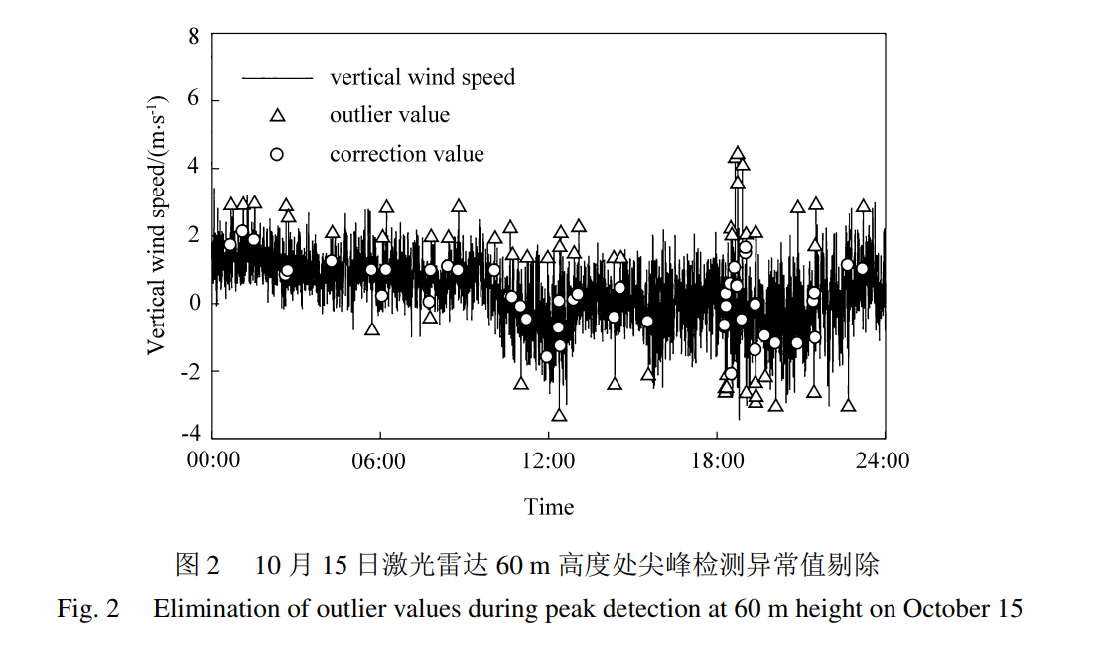
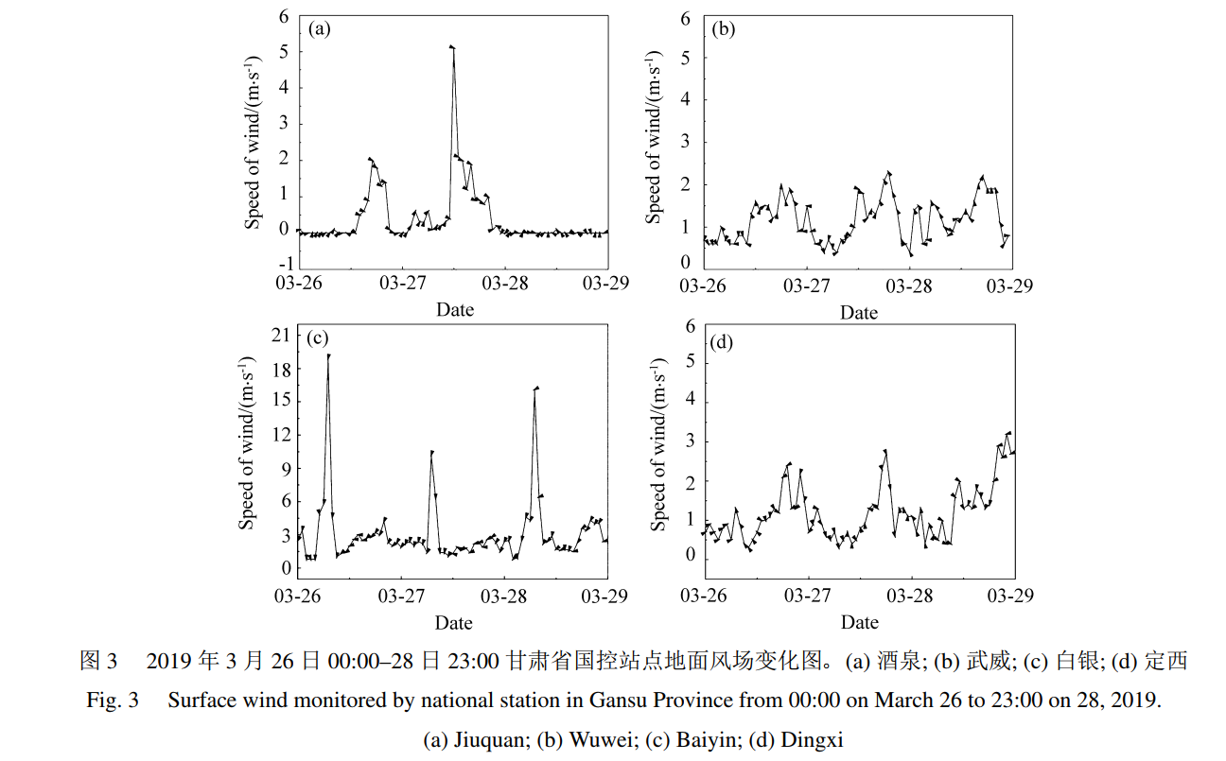
(Figures are recommended to be created using professional software such as Origin. Figure captions must be in both Chinese and English, and all text within the figure should be in English. The figure width should not exceed 16 cm in full column, and the height generally should not exceed 5 cm. Tick marks and labels on axes should be placed inside the axes (for the top and right axes, if there is no physical quantity, no tick marks are needed). Use Sonti, small size 5 for text. Figures must have a resolution of 600 dpi. Pay special attention to the correct notation of physical quantities and their units on both axes, as well as the wording of captions when multiple subfigures are present. For detailed figure requirements, please refer to “Requirements for Figures.”)
2 Experiment Results and Discussion
……please refer to table 2.
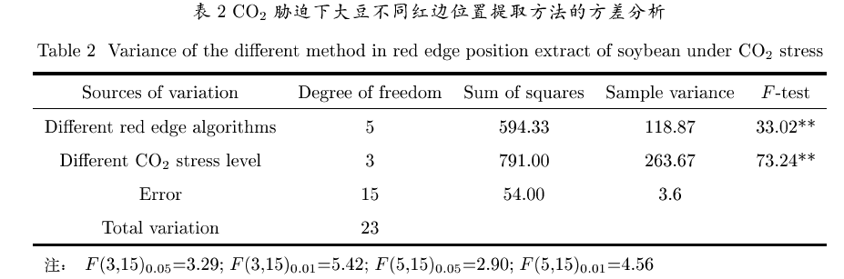
(Use a three-line table. Insert the table after the explanatory text in the main body. The text inside the table should be in English. The table caption should have Chinese on the top line and English on the line below, in Times New Roman, small size 5)
3 Conclusion
(Based on the results and discussion, summarize the key arguments derived from this study. The summary may include the following points: 1) interpretation of the results; 2) linking the results to the previously stated research objectives or hypotheses to highlight their significance; 3) comparing the results with those of other existing studies; 4) drawing clear conclusions wherever possible, with a summary of evidence supporting each conclusion. You may also indicate the limitations of the current work and provide an outlook for future research. It is imperative not to simply repeat the abstract or introduction.)

References：(Heiti size 5, Endnote is recommended)
Journal article：
Chinese journal
[1] Jing X, Hou Z H, Qin L A, et al. Measurement of whole layer atmospheric coherence length by observing stars in daytime [J]. Infrared and Laser Engineering, 2011, 40(7): 1352-1355.
靖 旭，侯再红，秦来安，等. 白天观测恒星测量整层大气相干长度 [J]. 红外与激光工程，2011，40(7): 1352-1355.
English journal
[2] Yu T Z, Yang Y X, Liu J G, et al. Design and evaluation of a unipolar aerosol particle charger with built-in electrostatic precipitator [J]. Instrumentation Science & Technology, 2018, 46(3): 326-347.
Monograph：
[3] Rao R Z. Light Propagation in the Atmospheric Turbulence [M]. Hefei: Anhui Science and Technology Press, 2005，(给出参考的页码范围).
饶瑞中. 光在湍流大气中的传播 [M]. 合肥：安徽科学技术出版社，2005，(给出参考的页码范围).
Xu X G, Wang J. UNL-VRTM, A Testbed for Aerosol Remote Sensing: Model Developments and Applications [M].
Kokhanovsky A. Springer Series in Light Scattering. Cham: Springer, 2019: 1-69.
Translated work：
[4] Born M, Wolf E. Principles of Optics [M]. Yang Jiasun, Transl. Beijing: Science Press, 1978: 182-190.
玻恩，沃尔夫. 光学原理 [M]. 杨葭孙, 译. 北京：科学出版社, 1978: 182-190.
Dissertation：
[5] Wang F. Analysis of Aerosol-Cloud Interaction Observed from Spaceborne sensors over Eastern China [D]. Chengdu: University of Electronic Science and Technology of China, 2015.
王富. 中国东部地区气溶胶-云相互作用卫星遥感建模研究 [D]. 成都：电子科技大学, 2015.
Technological standard：
[6] National Standardization Technical Committee. Quantities and units: GB3100-3102—93 [S]. Beijing: China Standard Press, 1994.
[7] GB17691-2018. Stage 6 Limits and measurement methods for emissions from heavy-duty diesel vehicles [S]. Beijing: China Standard Press, 2018.
GB17691-2018. 重型柴油车污染物排放限值及测量方法 (中国第六阶段) [S]. 北京: 中国标准出版社, 2018.
Patent：
[8] 刘加林. 多功能一次性压舌板：CN92214985.2 [P]. 1993-04-14.
Conference proceedings：
[9] He K M, Sun J, Tang X O. Single image haze removal using dark channel prior [C]. 2009 IEEE Conference on Computer Vision and Pattern Recognition, June 20-25, 2009, Miami, FL, USA. IEEE, 2009: 1956-1963.
[10] Genkova I, Long C, Besnard T, et al. Assessing cloud spatial and vertical distribution with cloud infrared radiometer CIR-7 [C]. Proceedings SPIE 5571, Remote Sensing of Clouds and the Atmosphere IX, November 30, 2004, Maspalomas, Canary Islands, Spain. 2004, 5571: 1-10.

Innovation Statement（To facilitate the review of the manuscript, please clearly explain what major innovations this paper presents compared with research results published domestically and internationally, especially abroad, in the past three years (including research papers previously published by this research group). You must specify which parts constitute original findings first publicly disclosed by the authors, either domestically or internationally.）

